CSE486.1
Quiz1
Ahadul Islam
1811386042
Submitted to: SAS3

Git:https://github.com/NSU-SU21-CSE486-1/1811386_SU21_CSE486_1/tree/main/Project/Version01/quiz%201

The project is made using java programming language and XML.

It is a very simple program . It open with taking four inputs from the user
Name, Date of Birth,NID,Blood Group. 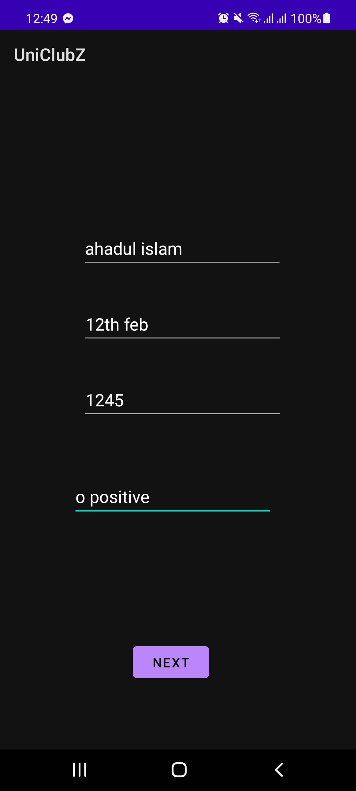
When the next button is clicked then the user is taken to enter their University and department of study ,Student ID,Study Level. The user also able to see the past information that they added as shown in the top part. 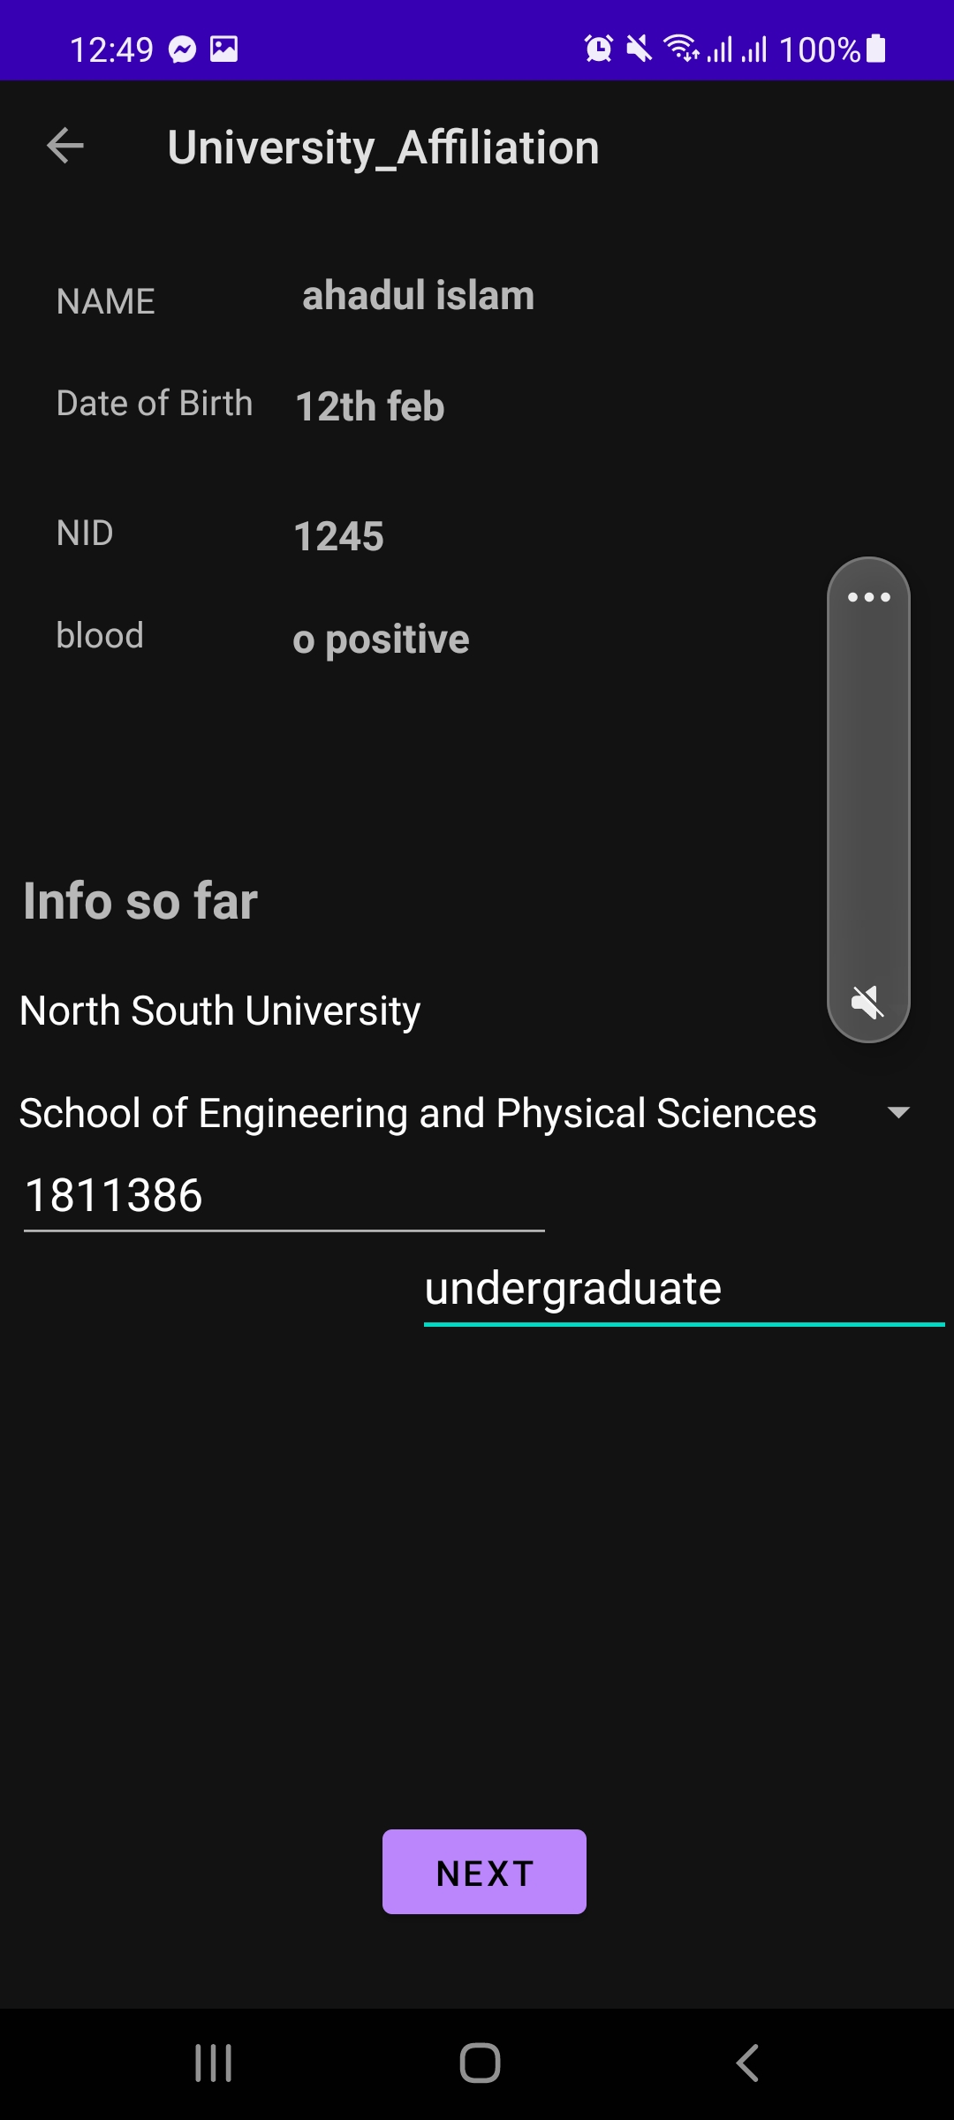

When the next button is clicked the User is taken to the “laststop screen” to display all the information given so far.
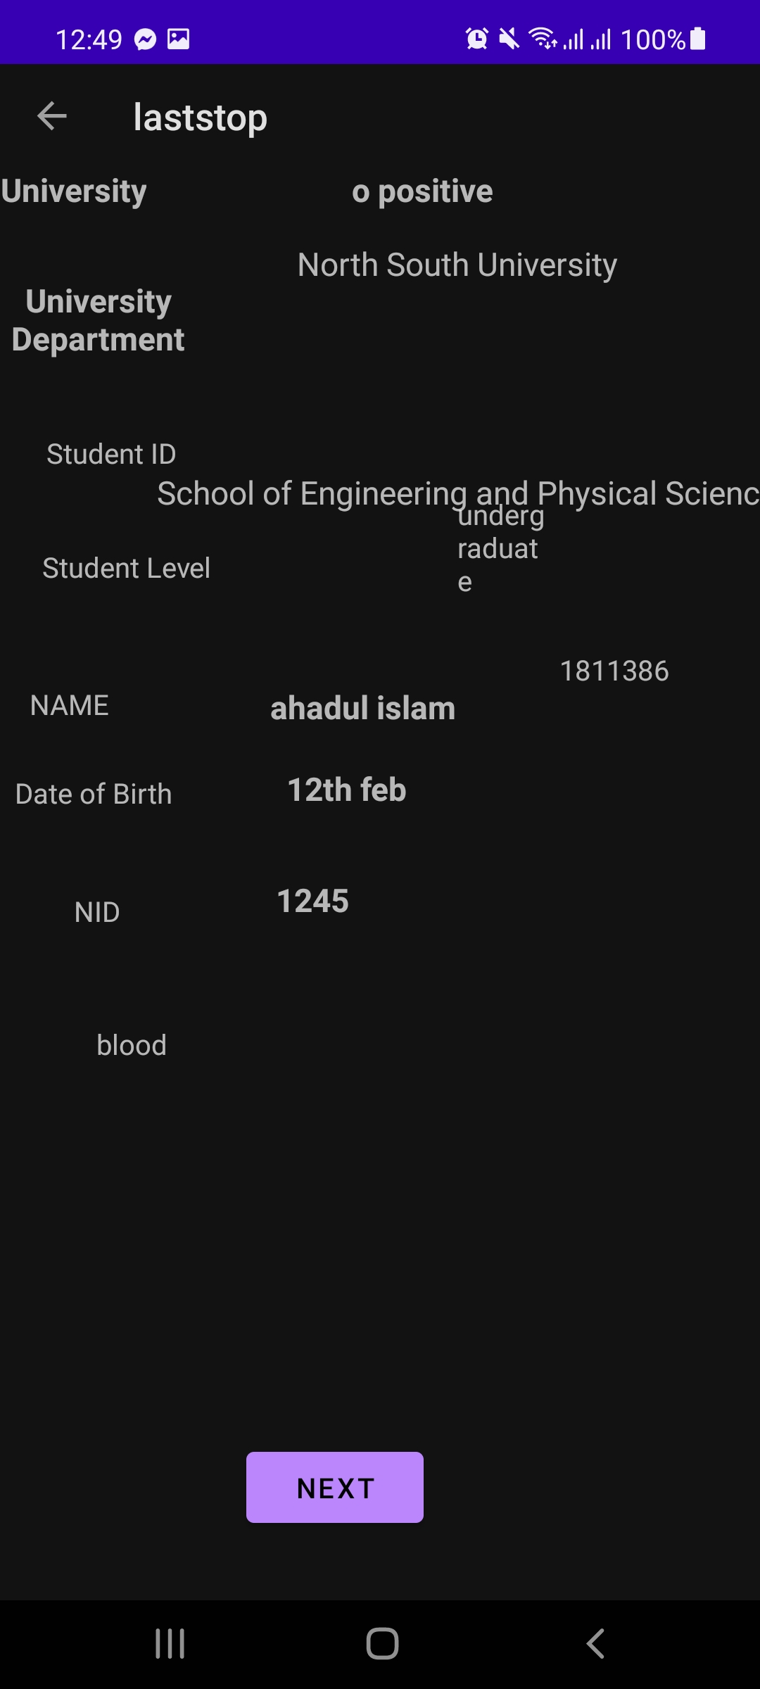
In this screen the user inputs the last two information email and phone number are given.
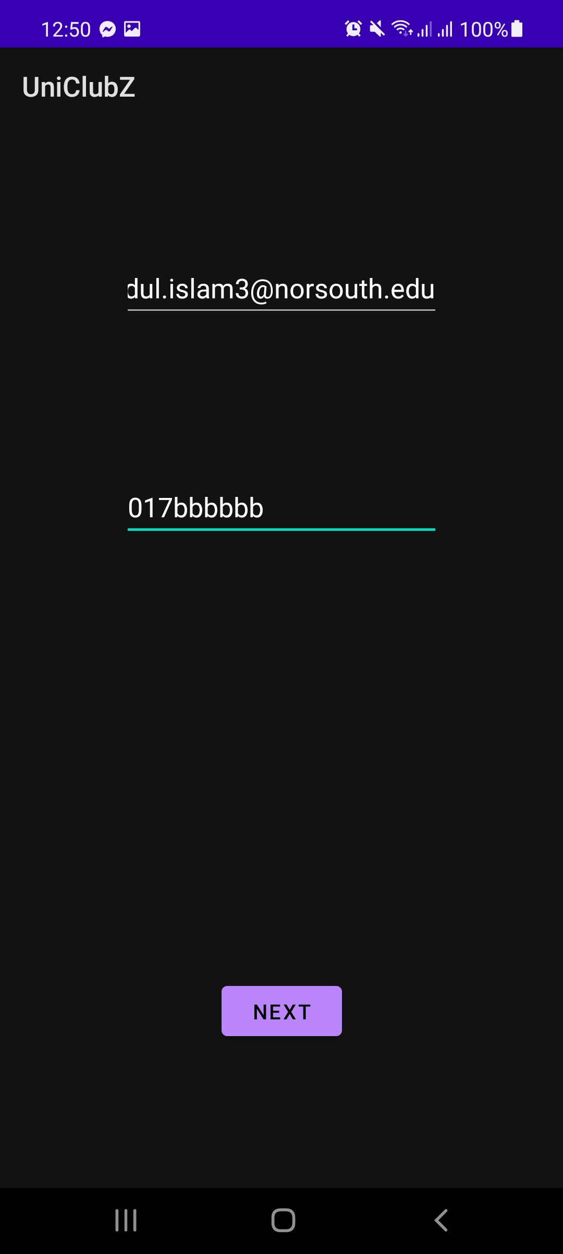

In the final screen are all information are displayed.

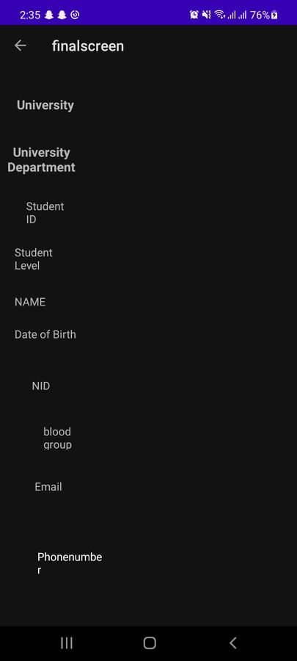

Challenges and problems
I was able do till the laststop screen smoothly and according the to question given however no matter what I tried I could not solve the issue . So in the last page on the phone number and email show up.
For some unknown reason the app crashed in the vitual phone . All the screenshots are from my live phone .
For another reason my Main activity XML and University Affiliation XLM displays are gone I had code out the XML for university affiliation hence the misaligned student ID and study level.

I thought the the quiz1 would have been possible to solve in 3 days but I underestimated the project and took longer.
I clearly learned alot from the project .
